5.1 User Interface Design: Login And Registration.
The wireframe below illustrates the proposed website design. As shown, the system provides four login portals for different user groups:
- Patient Portal
- Clinician Portal
- Staff Portal
- Administrator Portal
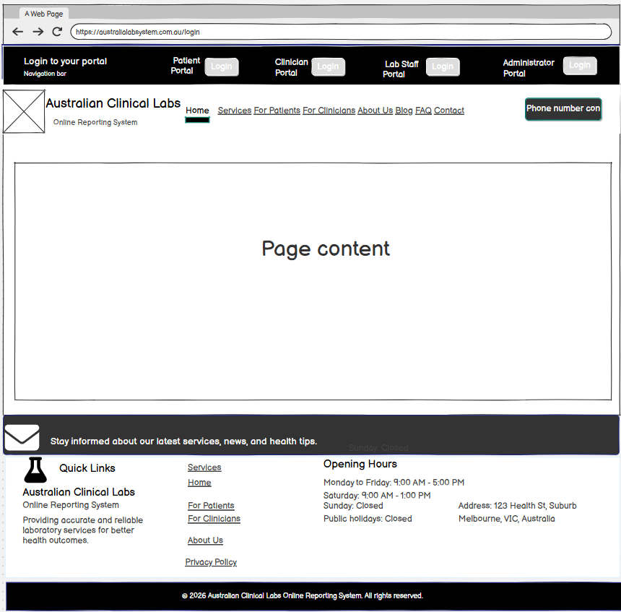
1. Patient Portal:
When the user clicks the Login button next to the Patient Portal option (located at the top of the screen), the patient is directed to the login interface. At this screen, the patient enters their email address (or username) and password to access the system.
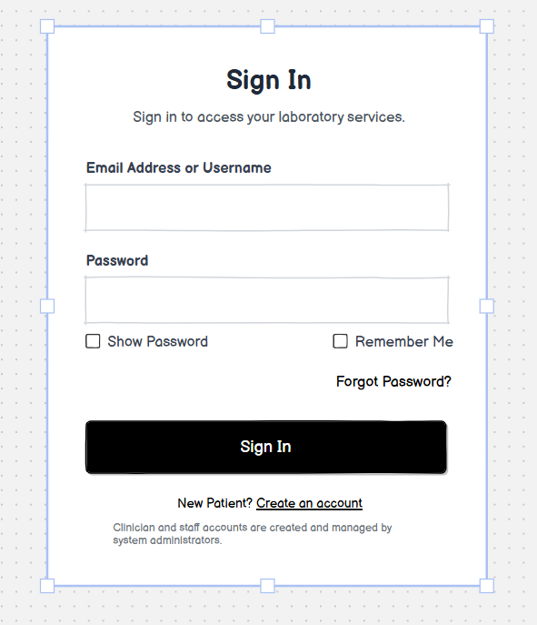
New Patient Registration:
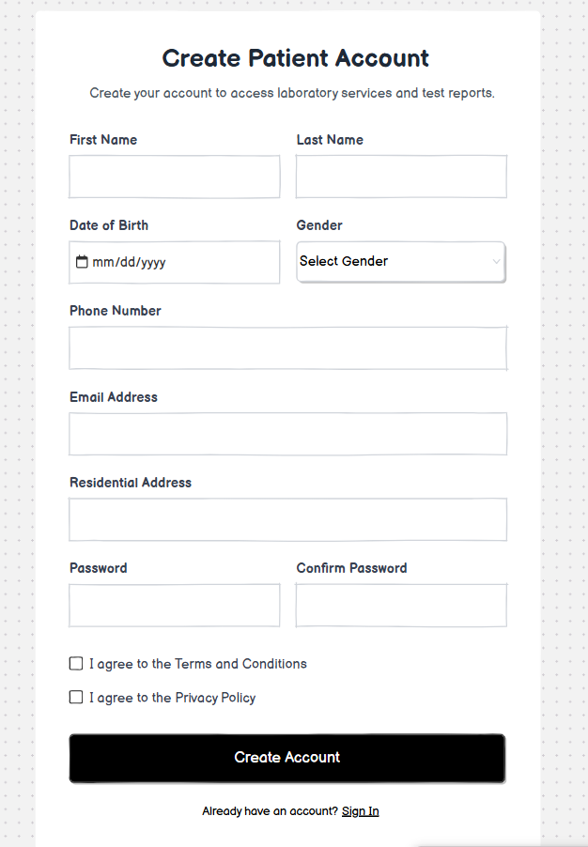
- Special Verification:
Unlike staff and administrator accounts, patient accounts are not provided by the system administrator. Therefore, patients must register and verify their own accounts by following the steps below.
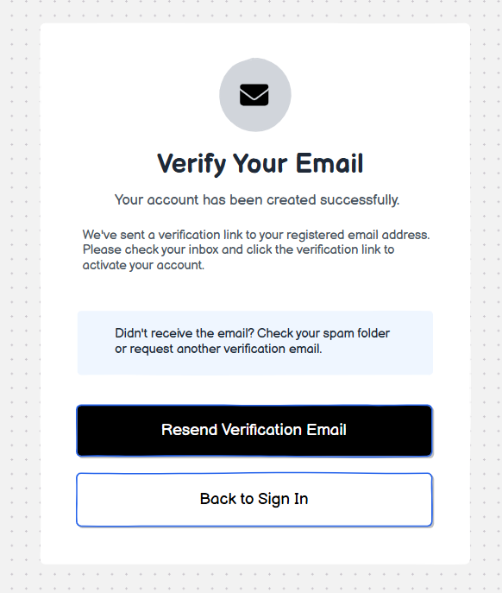
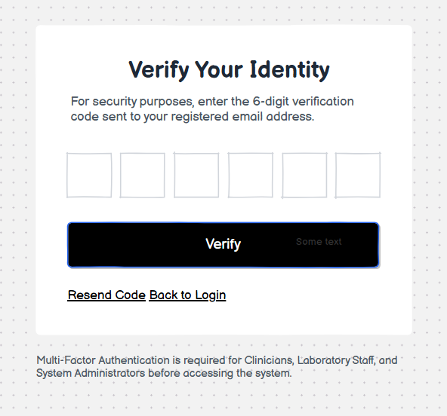
Reset Password: If patients forget their password, they can reset via Email.
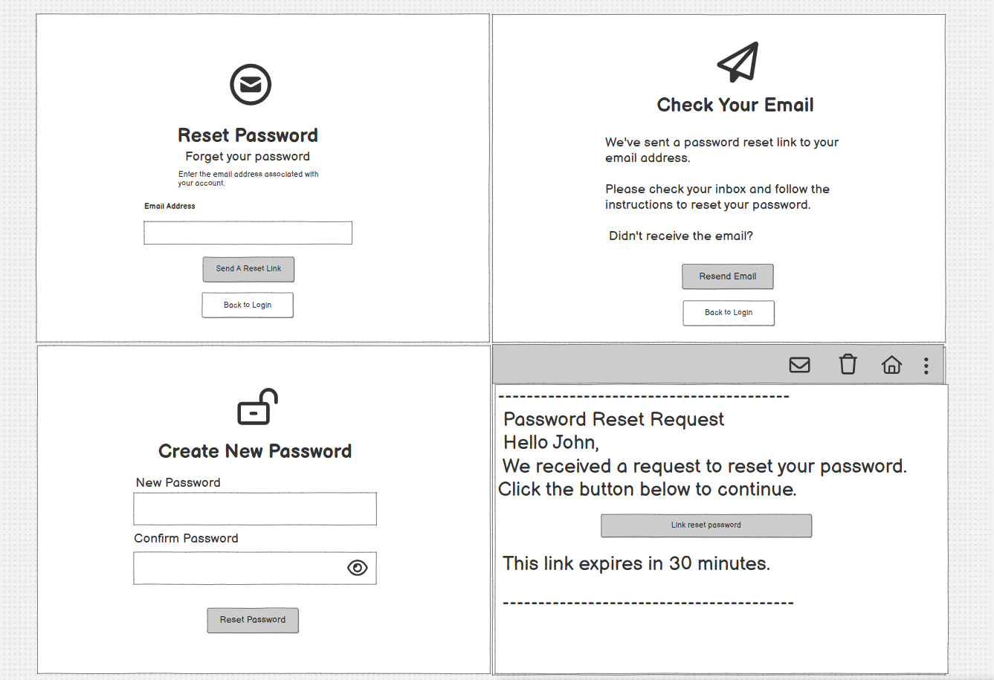
2. Clinician and Staff Portal:
These portals are intended for privileged users who cannot create their own accounts. Instead, their accounts must be created and approved by a system administrator.
The login process is the same as for the Patient Portal, where users enter their email address (or username) and password to sign in. However, if they do not already have an account, they must follow the account request process outlined below.
To access one of these portals, users click the Login button corresponding to their assigned portal.
Step 1. Click to Need an account or Contact Administrator:
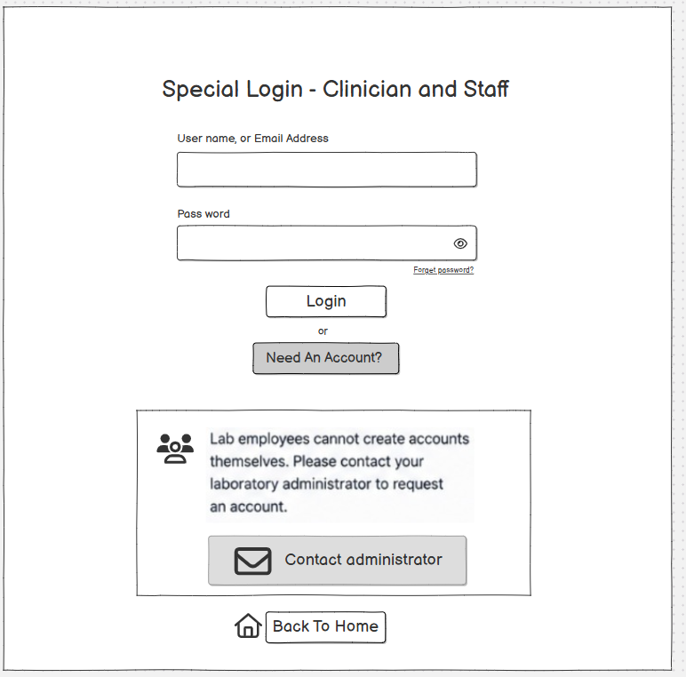
Step 2. The link directs users to the administrator's contact page, which includes the administrator's contact details and the administrative office information. Users can choose from several contact methods; however, they may also select "Send a Request" to submit an account request online.
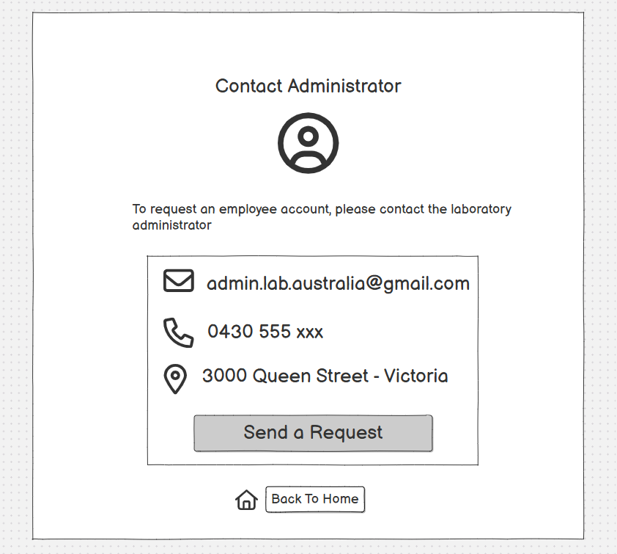
Step 3. Complete the required request form, submit it, and wait for the administrator's approval.
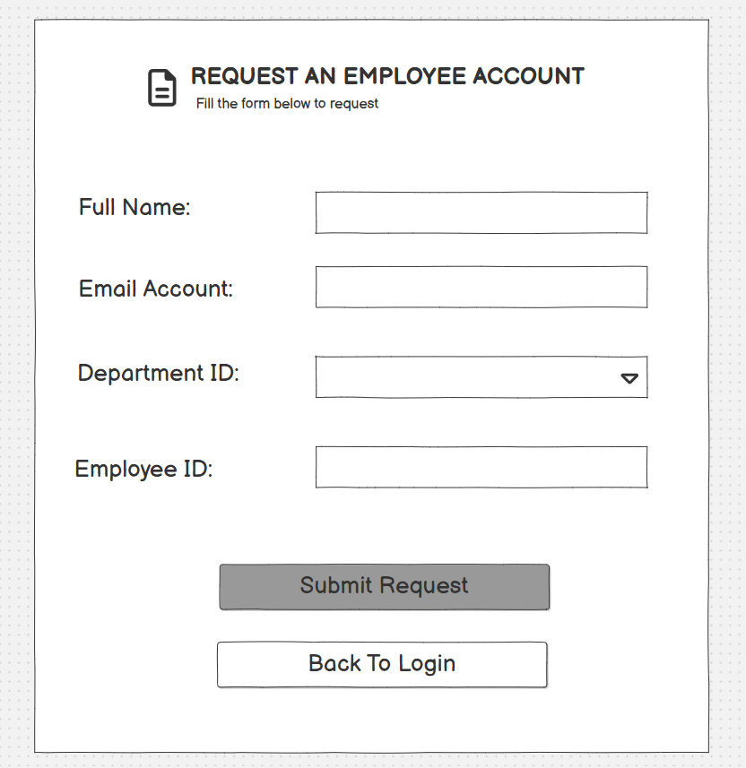
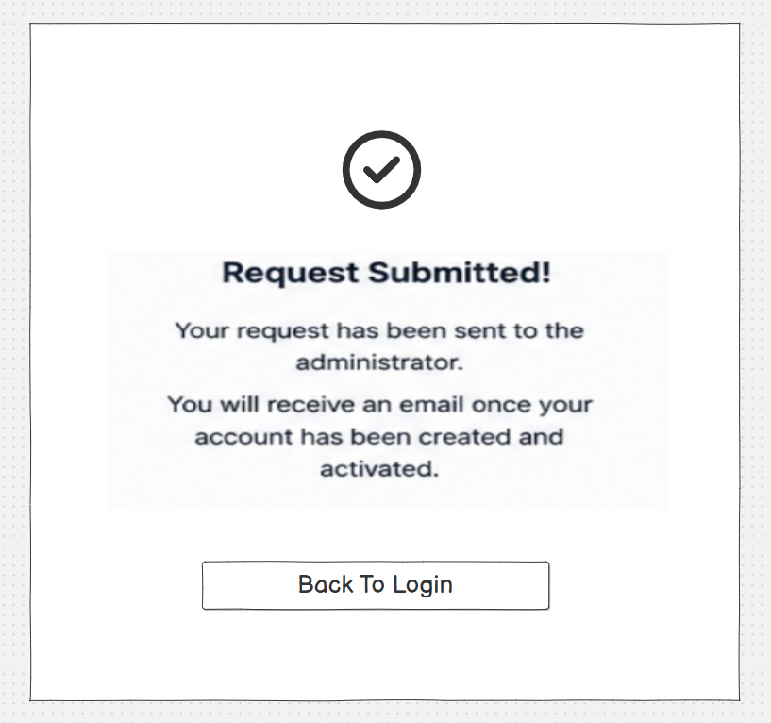
3. Multi-User Portal
The Staff Portal is shared by three staff roles: Receptionists, Specimen Collectors, and Laboratory Clinicians. All staff members access the system through the Staff Portal by selecting the corresponding Login button.
After successfully logging in using administrator-issued credentials, users are taken to the following interface:
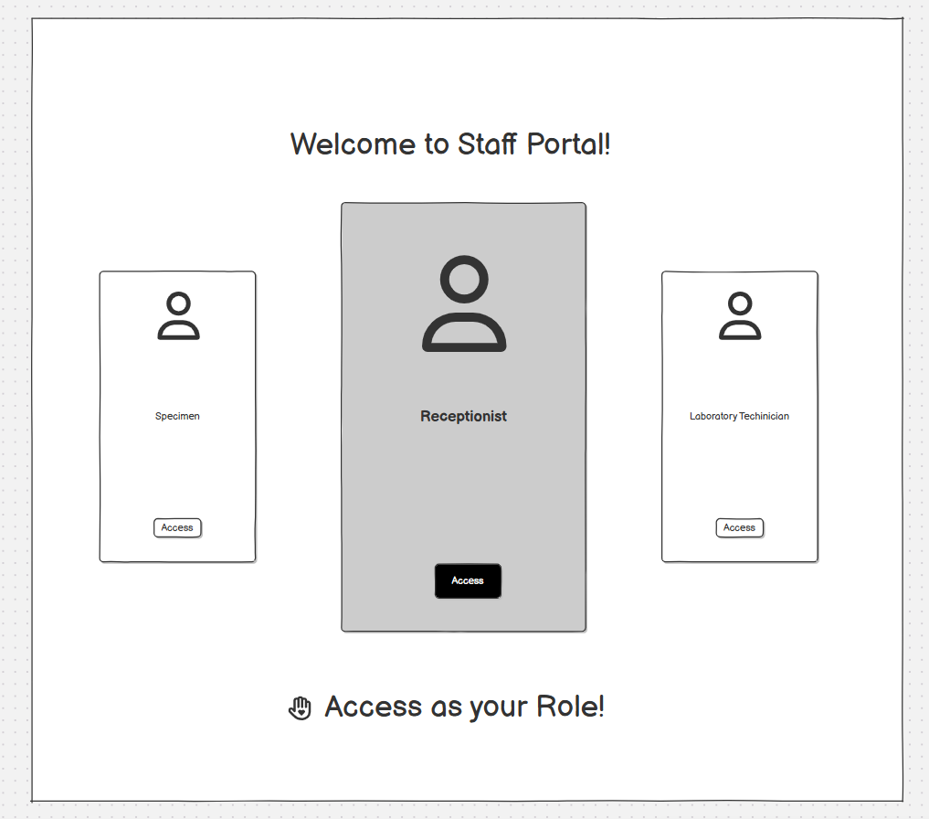

Features that are not assigned to a user's role are hidden. Users must select the role for which they have been authorized by the administrator in order to access the corresponding functions.

